**Smart Assignment Engine**

**Documentation**

**Introduction**

Smart Assignment is a web-based application designed to streamline the process of assignment management and enhance collaboration among students, teachers, and administrators. This project aims to leverage web development technologies to create an intelligent platform that automates assignment creation, submission, grading, and feedback, thereby improving the efficiency and effectiveness of the assignment process. Students can access the platform to view and submit assignments. The application allows for secure file uploads, ensuring the integrity and confidentiality of submitted work. The system provides notifications and reminders to students about upcoming assignment due dates and any updates or clarifications from teachers.

Smart Assignment aims to enhance the assignment management process, promote collaboration, and improve educational outcomes. By leveraging intelligent technologies and providing a user-friendly interface, the application streamlines administrative tasks, enhances student-teacher communication, and facilitates a more efficient and engaging learning experience.

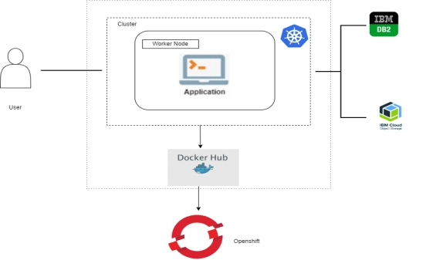

**Project Flow:**

To accomplish this, we have to complete all the activities listed below,

* **Define Problem / Problem Understanding**
  + Specify the business problem
  + Business requirements
  + Literature Survey
  + Social or Business Impact.
* **Creating a User Interface**
  + Create a User Interface using HTML, CSS/Bootstrap, and JavaScript, where the user will interact and give input.
* **Database Connection**
  + Creating necessary Schemas and Tables
  + Create a Cloud Object Storage to store multimedia data.
* **Flask Application**
  + Creating python’s flask web framework to connect the front end with the back end services.
* **GitHub**
  + Pushing all the files to github by using git commands
* **Containerization**
  + Containerize your application as a docker image and push it into Docker Desktop
  + Push the image to Docker Hub.
* **Kubernetes**
* **Creating a YAML configuration file**
* **Deployment Application in Openshift**
  + Deploying with Git Repository
  + Deploying with Docker Image
  + Deploying with YAML File
* **Mentorship Program** :Smart Assignment Engine
* **Category:** Cloud Application Development
* **Skills Required:** Flask Integration,HTML,CSS,Bootstrap,Docker,Kubernetes,IBM D2B

**CHAPTER 1**

**Define Problem / Problem Understanding**

* 1. **Specify the business problem**

**Smart Assignment** is a web-based application designed to streamline the process of assignment management and enhance collaboration among students, teachers, and administrators. This project aims to leverage web development technologies to create an intelligent platform that automates assignment creation, submission, grading, and feedback, thereby improving the efficiency and effectiveness of the assignment process. Students can access the platform to view and submit assignments. The application allows for secure file uploads, ensuring the integrity and confidentiality of submitted work. The system provides notifications and reminders to students about upcoming assignment due dates and any updates or clarifications from teachers.

Smart Assignment aims to enhance the assignment management process, promote collaboration, and improve educational outcomes. By leveraging intelligent technologies and providing a user-friendly interface, the application streamlines administrative tasks, enhances student-teacher communication, and facilitates a more efficient and engaging learning experience.

* 1. **Business requirements**

Business requirements of a **smart assessment engine** encompass several key aspects.

* Firstly, it should possess robust functionality to create, deliver, and evaluate assessments efficiently. This includes the ability to generate various question formats, support adaptive testing, and provide instant scoring and feedback to users.
* Secondly, it should offer seamless integration with existing learning management systems or platforms, enabling easy administration and data management. Additionally, the smart assessment engine should prioritise data security and privacy, ensuring the confidentiality and protection of sensitive user information.
* It should also have scalability to handle a large number of concurrent users and accommodate future growth.
* Furthermore, the engine should be adaptable and customizable to meet the unique needs of different educational institutions or organisations, allowing for personalised branding and tailored assessment experiences.

Lastly, it should offer comprehensive analytics and reporting capabilities, enabling administrators to gain insights into performance trends, identify knowledge gaps, and make data-driven decisions to improve the assessment process and overall learning outcomes.

* 1. **Literature Survey**

A literature survey of smart assessment engines reveals a significant body of research focusing on the development and implementation of intelligent systems designed to revolutionise the assessment process. Studies demonstrate the potential of smart assessment engines to improve efficiency, accuracy, and fairness in evaluating student performance while providing personalised feedback and adaptive learning experiences. Furthermore, research highlights the importance of designing user-friendly interfaces, ensuring the privacy and security of data, and addressing potential biases and ethical concerns associated with these systems. Overall, the literature showcases the promising role of smart assessment engines in transforming educational assessment practices and advancing the field of assessment technology.

**1.4 Social or Business Impact.**

**Social Impact:** It will make the life of a student on campus much easier. Professors also no need to carry the big pile of notebooks submitted by students and the transparency of marks allotment also willbethere.  
  
**Business Model/Impact**: It will also give a positive impression about the university around the time of admissions and can be made by digitizing the campus.

**CHAPTER 2**

**Creating a User Interface**

**2.1: index.html**

Index.html is a homepage, this html page will have it as the landing page of our college website.

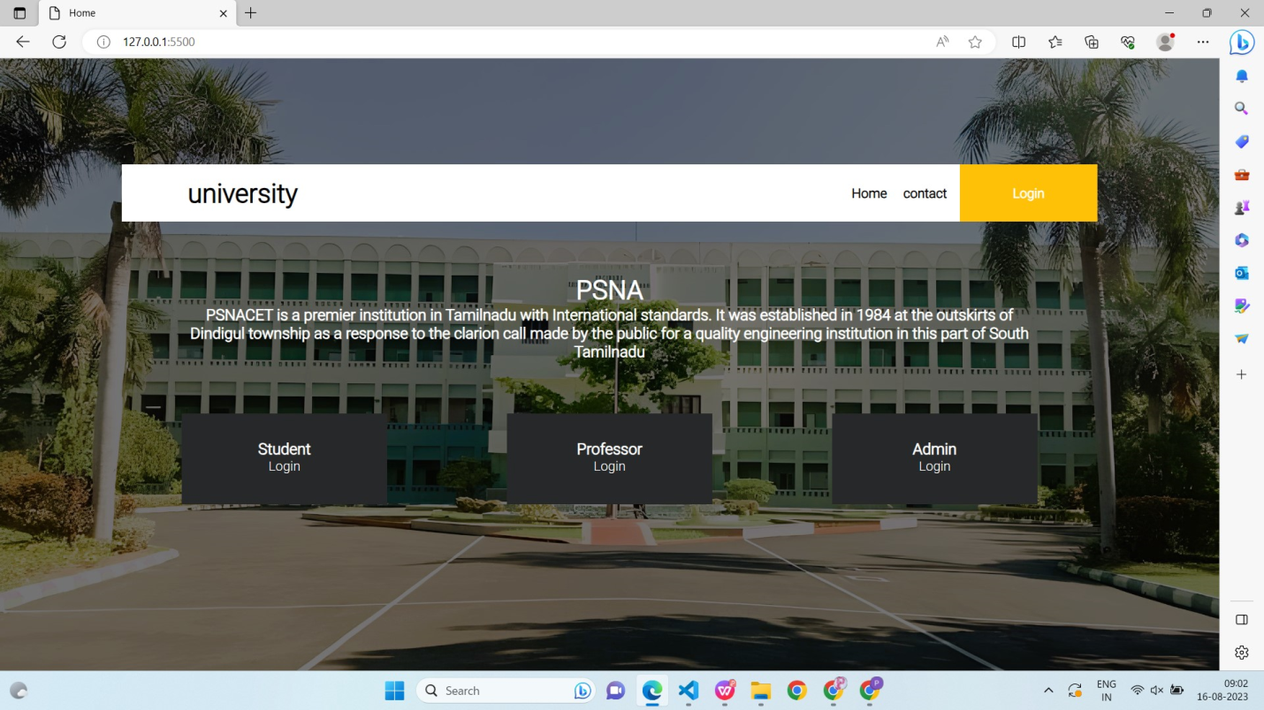  
  
  
  
As we can see in the above picture of index.html where we have login options for students, professors and Admin(who manages the data).   
  
If we click on the contact button it will take us to the contact page that we code as contact.html  
  
  
**2.2:contact.html**  
In this html page, we are going to give a form where users can give feedback for any issues they are facing or can also contact the concerned person by using the contact information provided.  
  
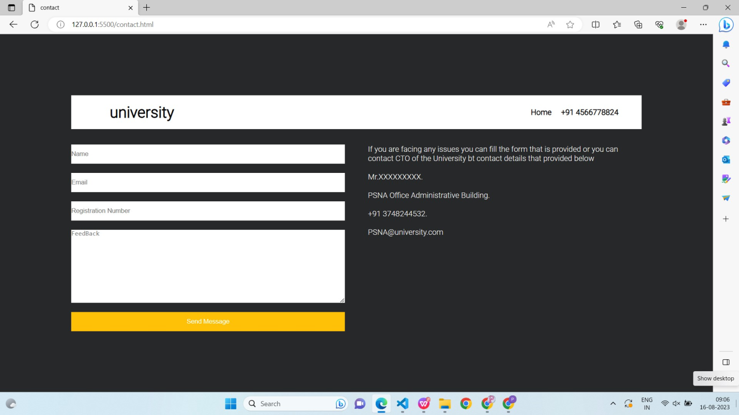  
  
  
If we want we can save this feedback in the database and get it to the admin page so that admin can see and respond to the issue.

**2.3login.html**  
In this html page, all the people will log in. Here we don't have a register section because registration will be done only by the admin in their login. When an admin registers a mail will be sent. Here they will use that login credentials.

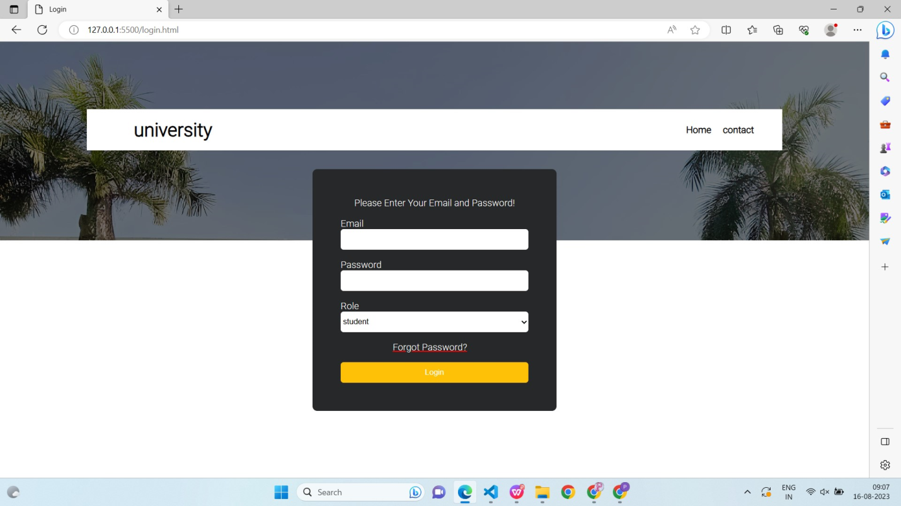  
  
  
**2.4:adminprofile.html**  
In this html page, when the admin login with their credentials with the backend code of routing we will find whether it's admin or not. If yes then we will route him from login to this html page.   
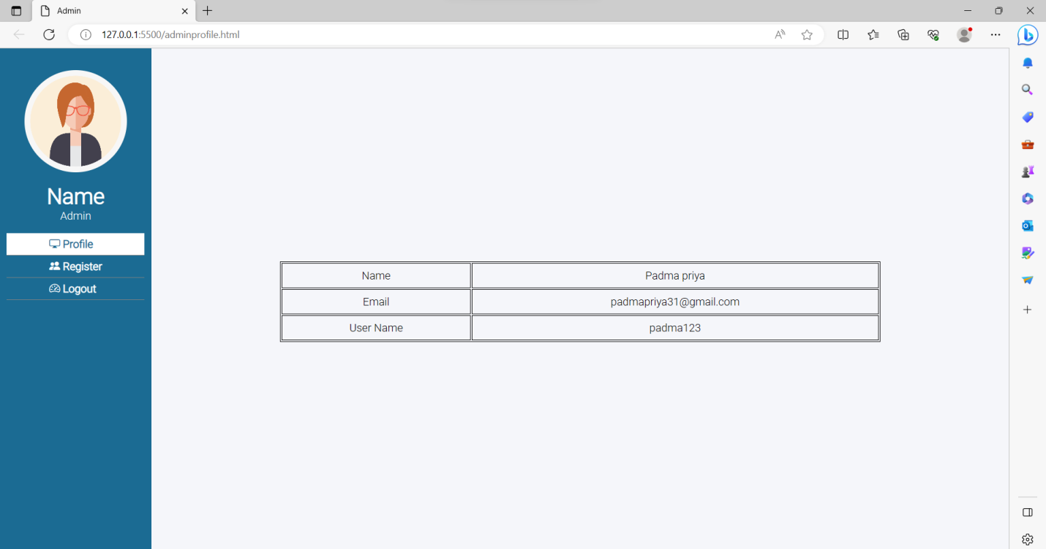  
  
  
Once they successfully log in as admin, adminprofile.html is the page they will be redirected to where they can see their details like photo ( which is on the left side top ) username, email and name. We can also display more info like phone number, etc…

**2.5: adminregister.html**

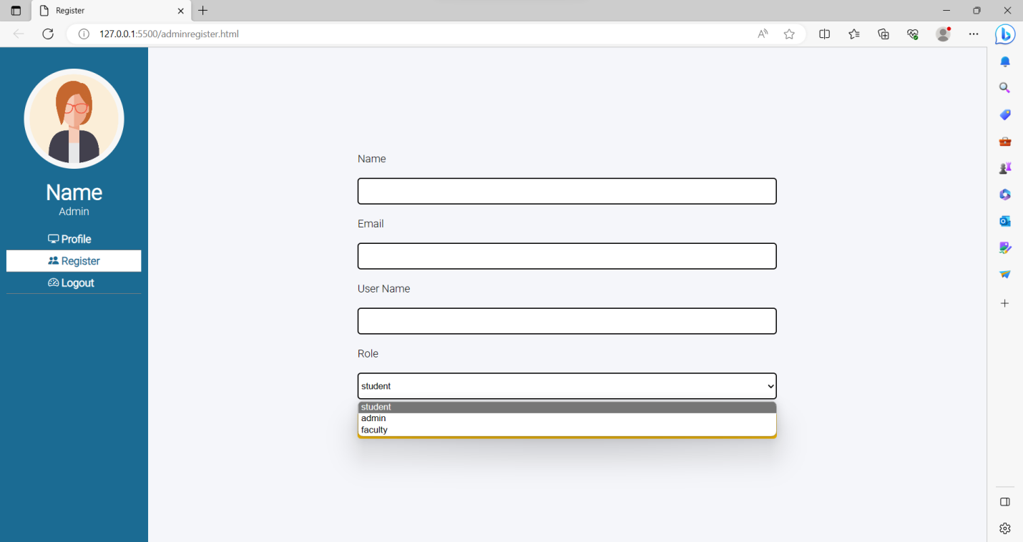  
  
**2.6: studentprofile.html**

This html page is also the same as adminprofile.html. Where students can see all the details of the student along with a profile picture, here also we can add more like the year, registration number,  branch, etc…

**2.7:studentsubmit.html**  
  
When students click on the assignment button they can see a list of assignments that they have to submit.

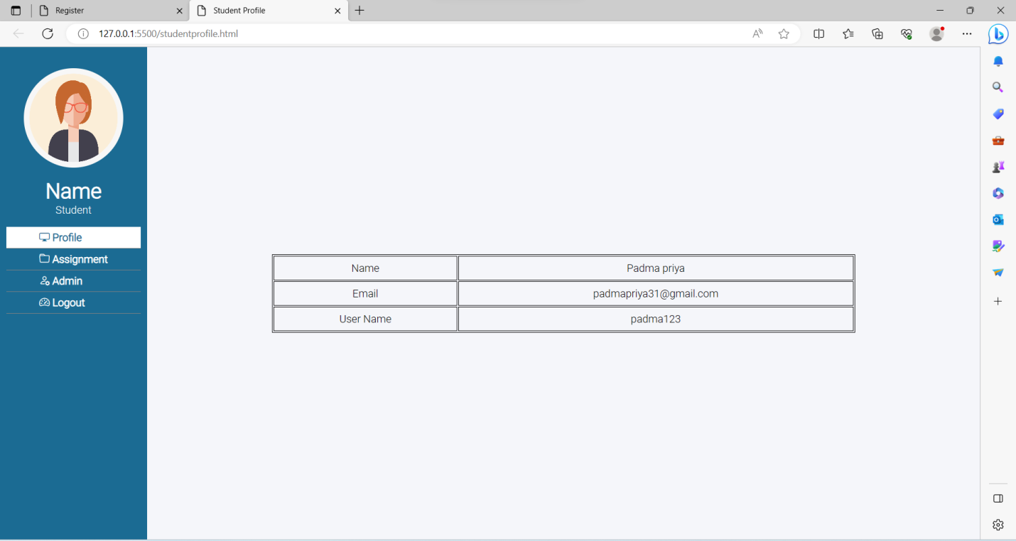  
  
As you can see,  here is the list of some assignments where students can know what and how many assignments they have to do and the last date of submission.  
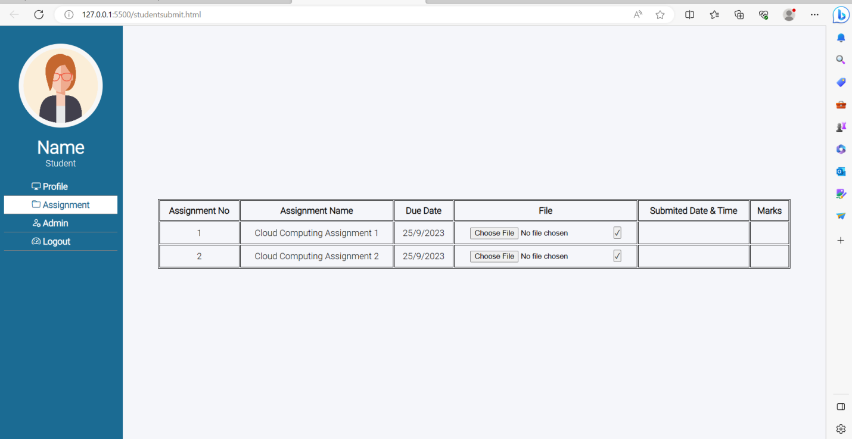  
  
  
Students can click on the choose file button( highlighted in the orange color box), Here we have asked them to upload only pdf files.  
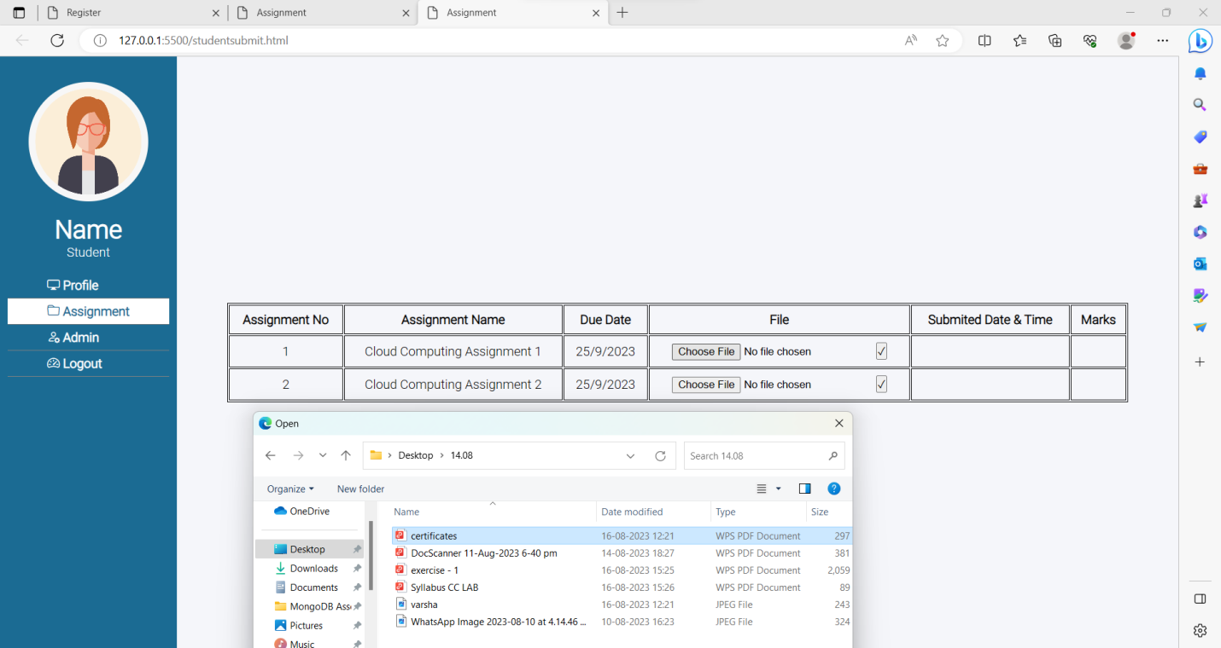  
Once they selected and submitted the file by clicking on that tick button (2), once they submitted the file. The will be submitted into object storage in the backend and the submit time will be shown for the students next to the submit button.

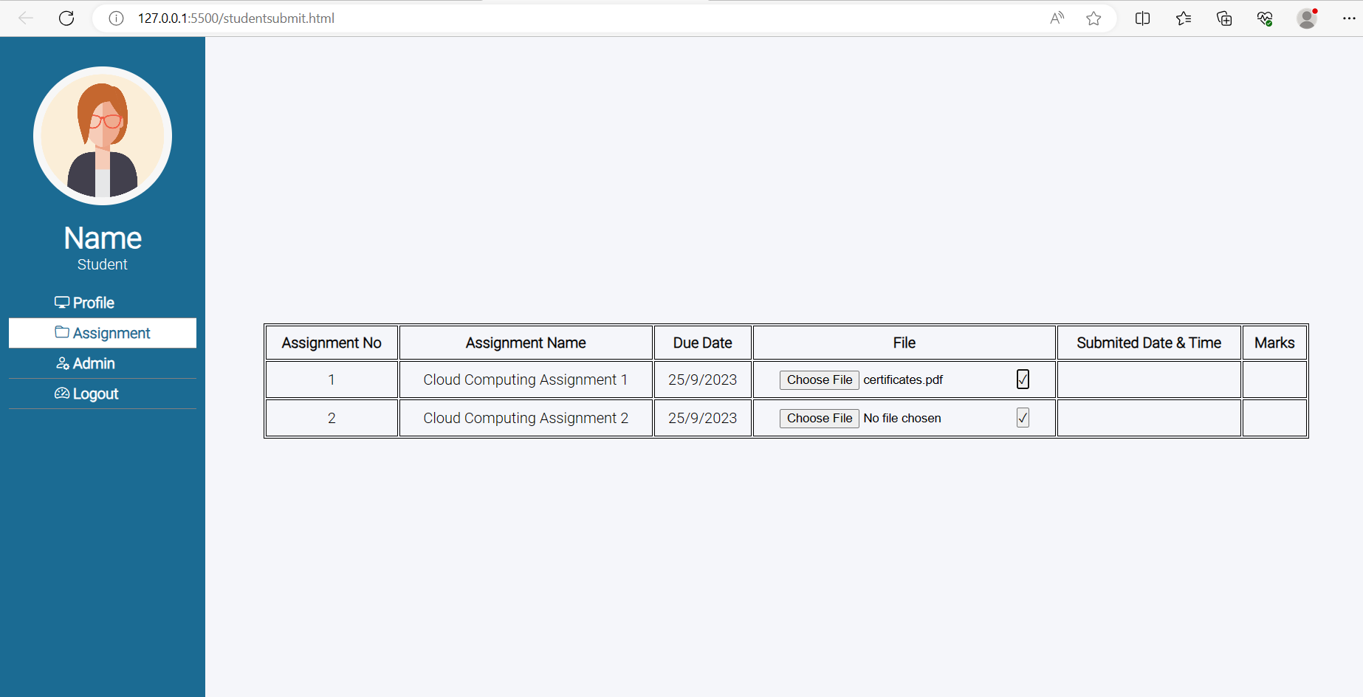  
  
  
  
Note: Here we can also make a drop down where students can select subjects and based on the subject students can see the assignments of the particular subject.  
  
Note: Marks ? None — means not yet assigned.  
  
Admin -  Contact Admin so, it takes us to the contact.html page  
  
Logout - Same as it does in the admin page too. It will log out the user and redirect to index.html  
  
**2.8:facultyprofile.html**  
In this html page, same as other profiles pages. We will have all the information about the faculty. Here instead of making three different html pages we can make it into a single page but need to figure the info we have shown, then we can make a dynamic page regarding it. To make it more dynamic it is a little bit tricky.  
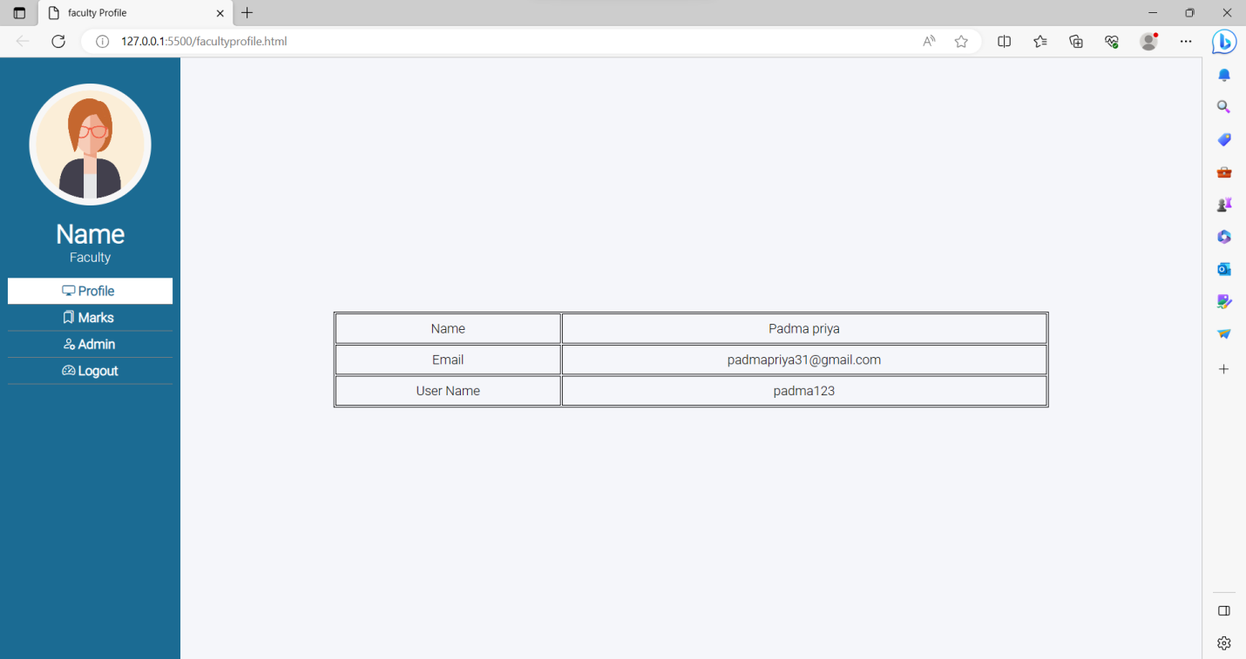  
**2.9:facultystulist.html**  
When you click on the marks button you will be redirected to this html page. In this, we can see all the lists of students that are enrolled for this course you are teaching.

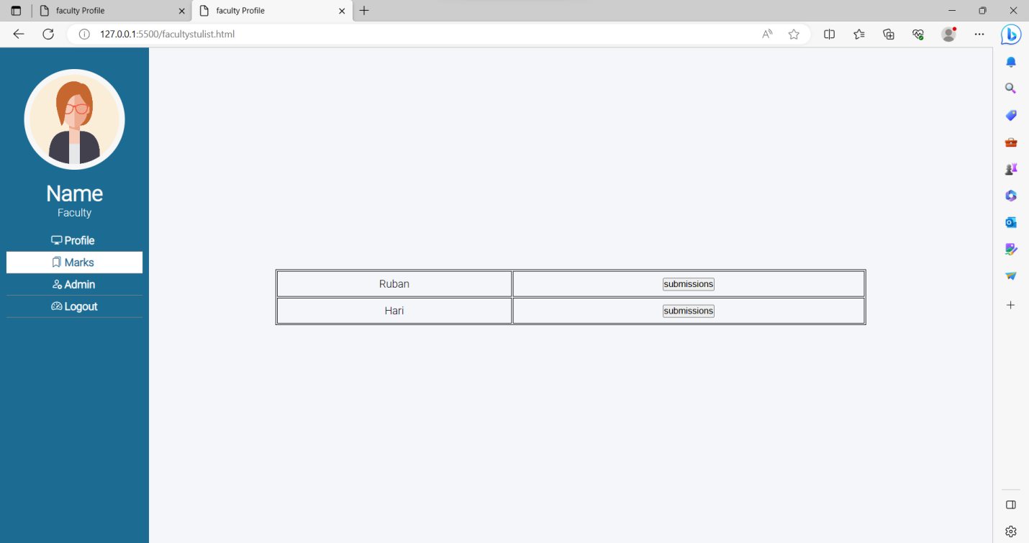  
  
  
  
Now to see the submissions they have done, you click on the submissions button ( highlighted in the orange color box in below picture)

When you click on the submissions button you will be redirected to the facultymarks.html   
  
**2.10:facultymarks.html**  
In this html page, we will see the submissions made by the student and also we can give the marks.

Here you can see the table, but only with 1 submission, because previously just above we have submitted only one file.   
  
Faculties can click on the download button, it will open the file in a new tab. Where you can see the file or you can download the file to your computer.  
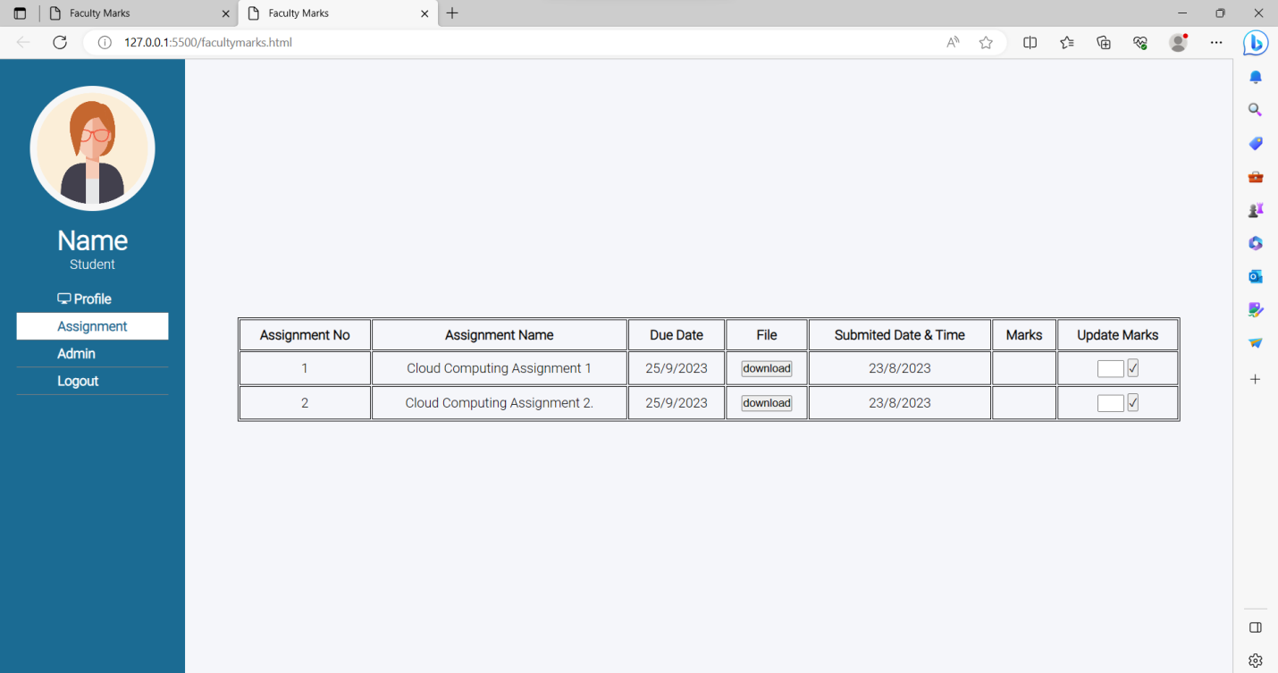  
  
To download the file click, on that download button ( highlighted in orange color)

**CHAPTER 3**

**Database Connection**

**3.1: Creating Register Table**

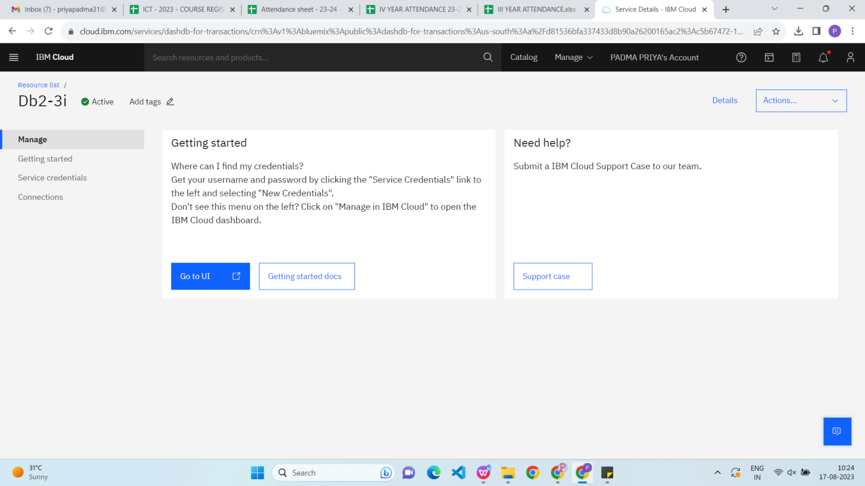

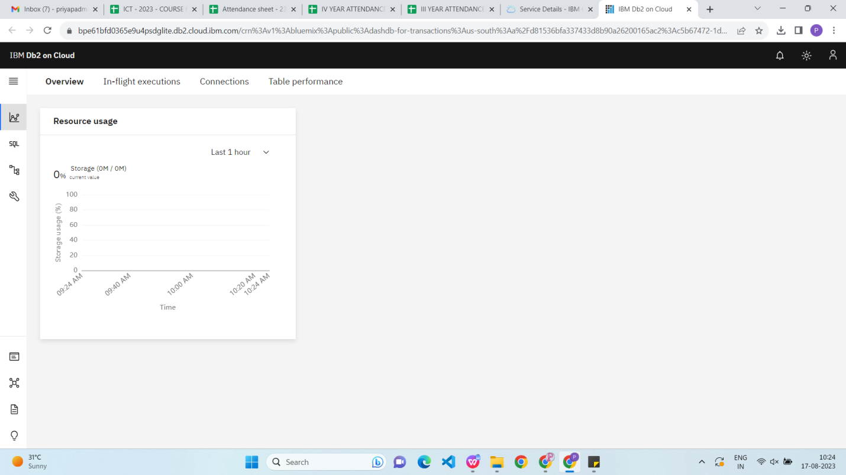

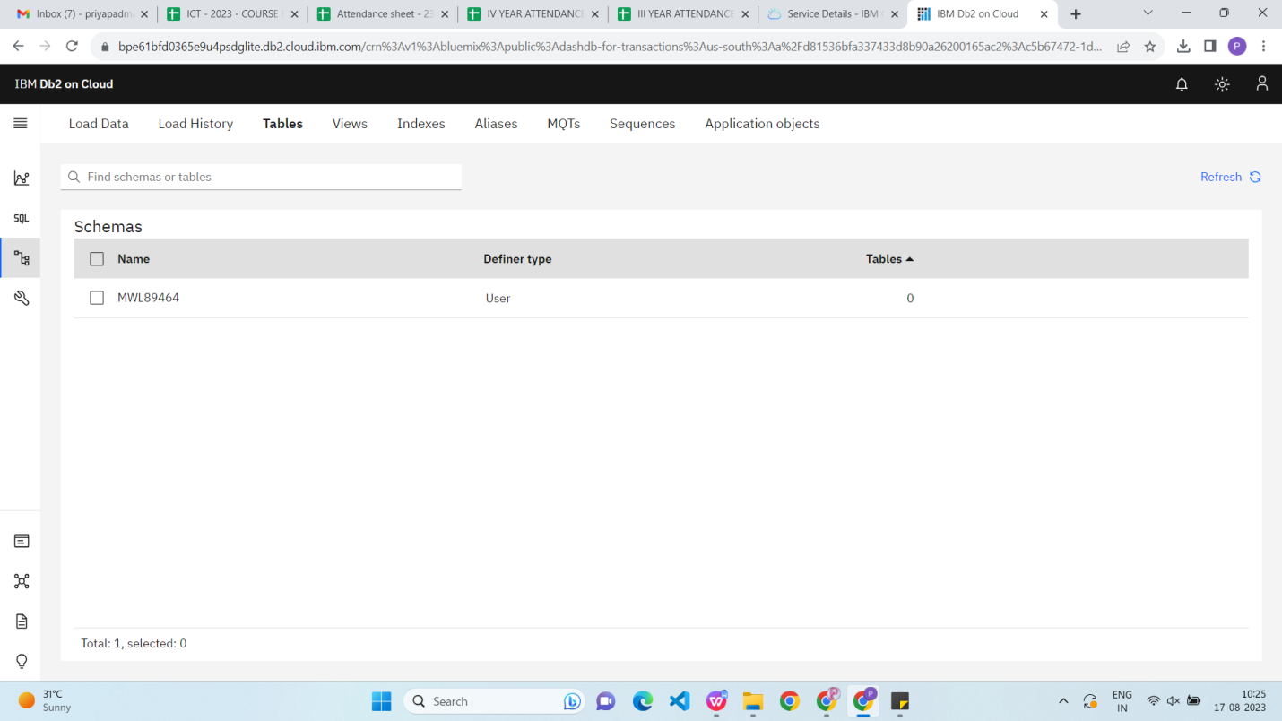

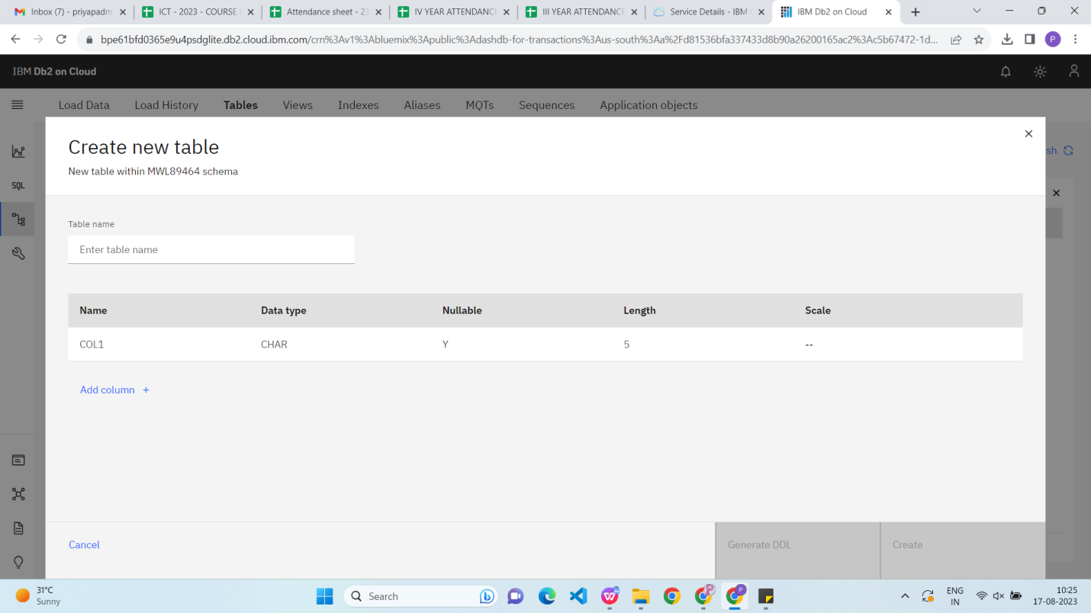

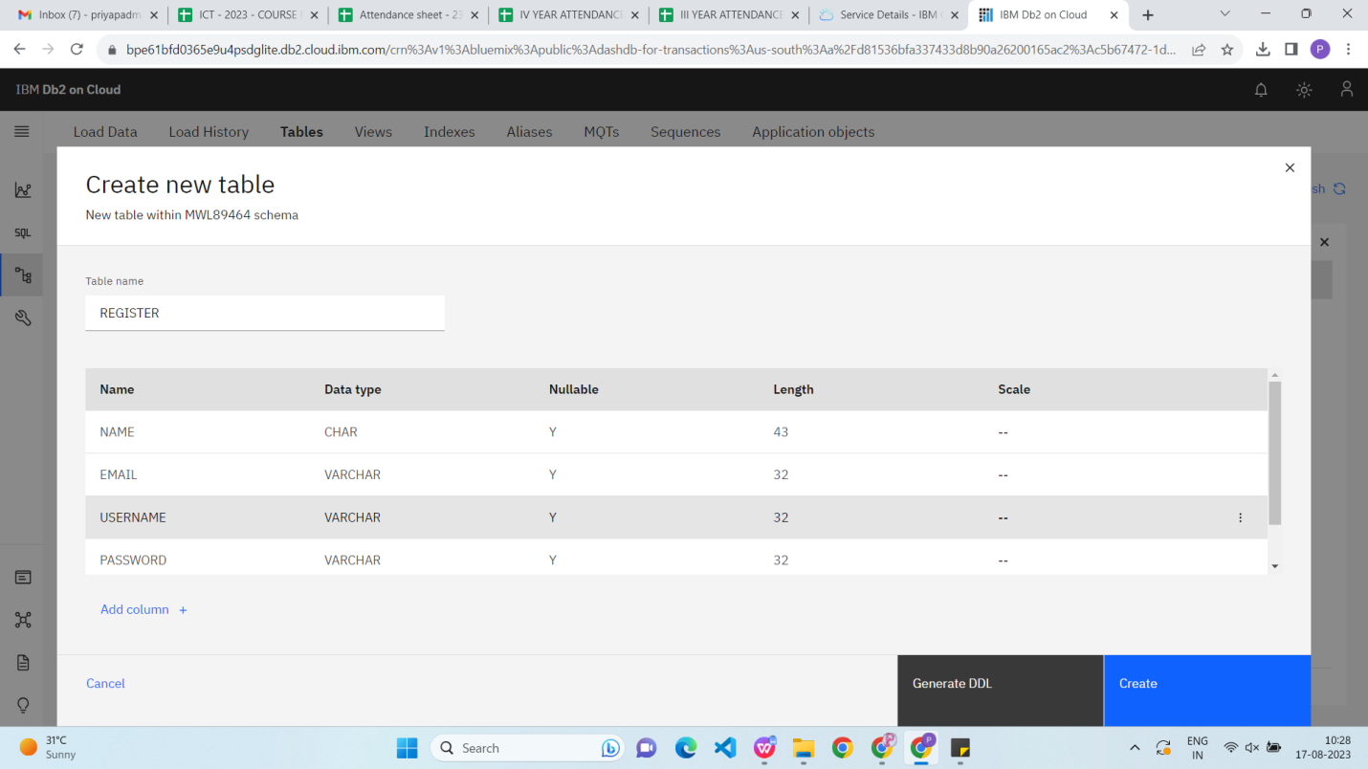

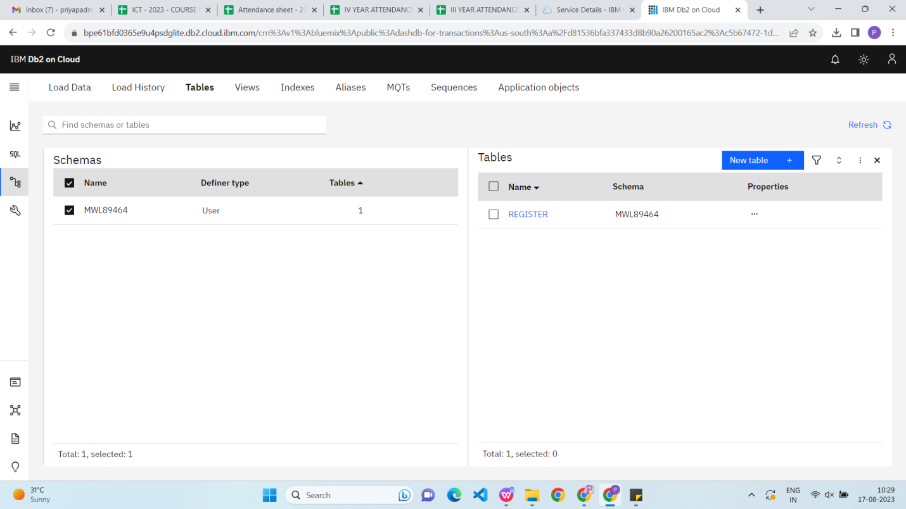

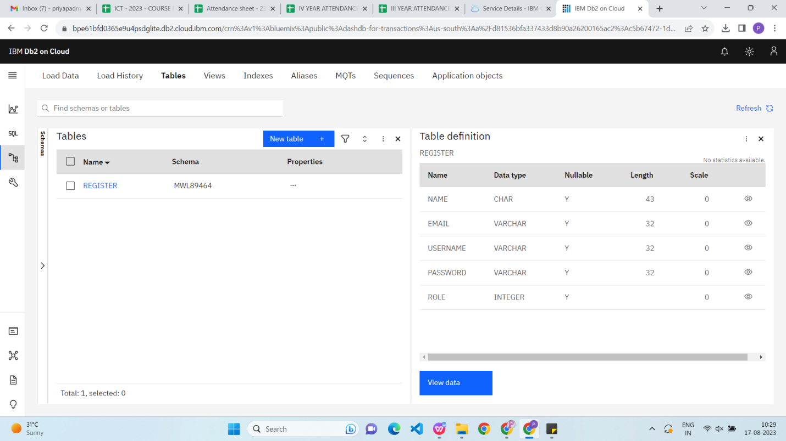

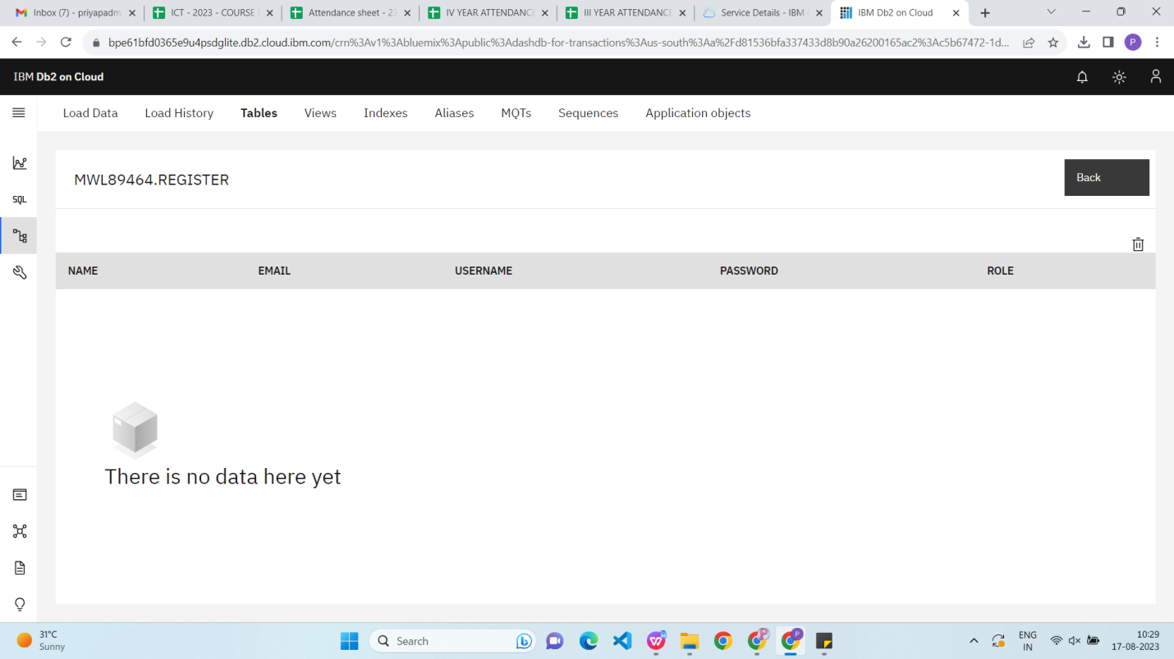

**3.2: Creating Submit Table**

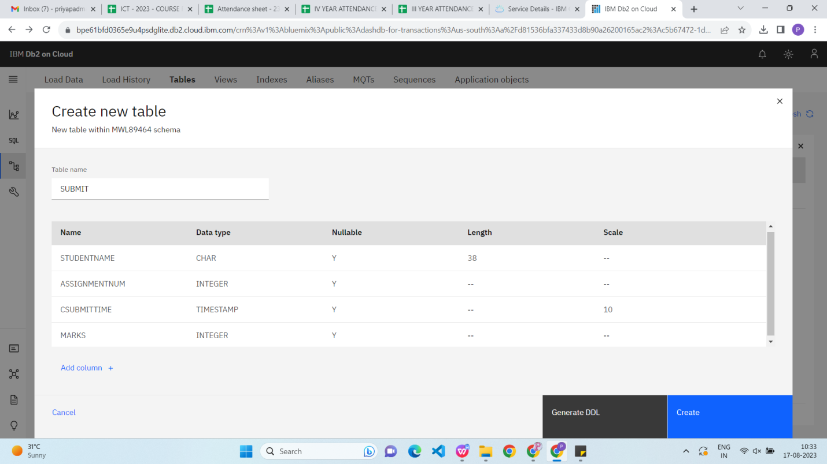

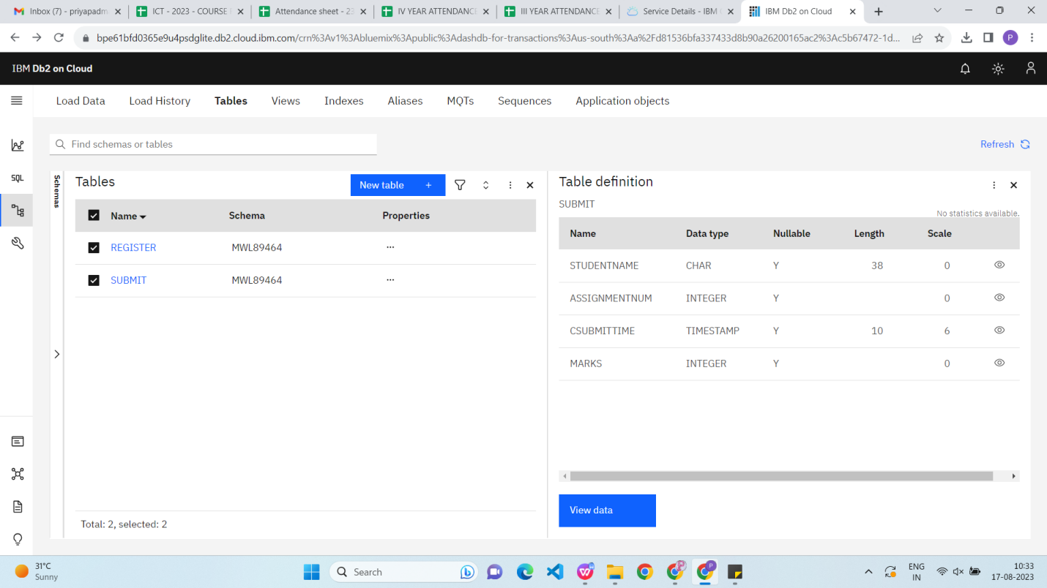 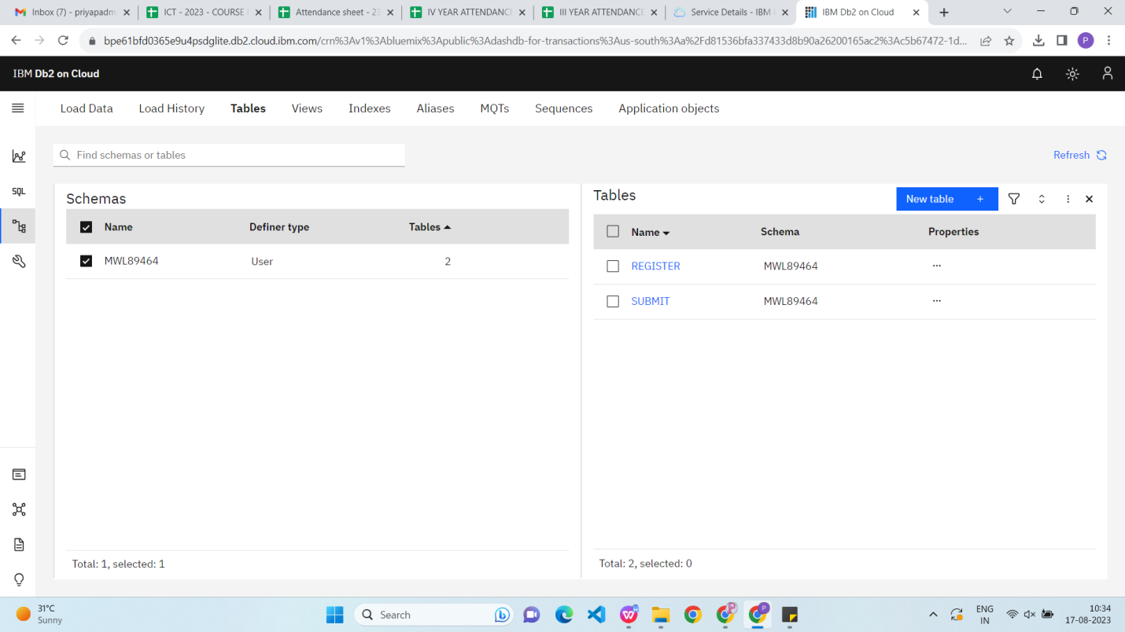

**3.3 Creating a Object Storage**

